According to Intelli, the Netherlands medical devices market was valued at USD 2137 million in 2024 and is projected to reach USD 5584.91 million by 2032, growing at a CAGR of 13.66% from 2025 to 2032.

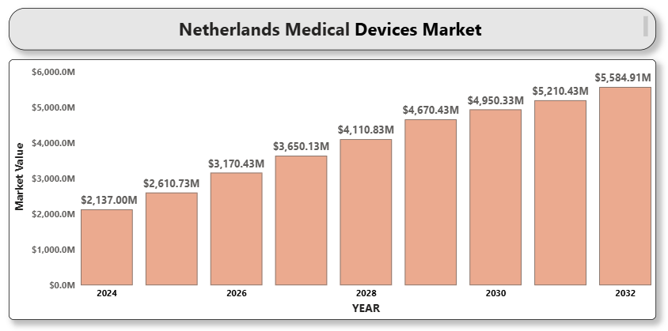

The Netherlands medical devices market is witnessing rapid growth, driven by technological innovation, strong regulatory support, and a robust healthcare infrastructure. The aging population and rising incidence of chronic diseases are increasing demand for advanced diagnostic, therapeutic, and monitoring devices. The Dutch government’s support for healthcare digitization, along with high public healthcare spending and early adoption of AI and IoT-enabled devices, contributes significantly to the expansion of this market. The country’s strategic location, highly skilled medical workforce, and strong logistics network also position it as a hub for medical technology development and distribution in Europe.

**NETHERLANDS MEDICAL DEVICES MARKET DEFINITION**

Medical devices refer to instruments, machines, implants, and software intended for medical purposes such as diagnosis, prevention, monitoring, or treatment of diseases and conditions. These devices range from simple tools like thermometers and syringes to complex technologies like MRI scanners, surgical robots, and wearable health trackers. In the Netherlands, the sector includes both conventional and smart medical devices used in clinical settings and at-home care environments. The integration of connectivity, miniaturization, and real-time analytics is transforming traditional medical practices and improving patient outcomes.

**NETHERLANDS MEDICAL DEVICES MARKET OVERVIEW**

The Netherlands offers a dynamic environment for the medical devices market, with early adoption of emerging technologies, strategic investment in healthcare research, and strong export potential. The country’s focus on personalized care, home healthcare, and remote patient monitoring is accelerating demand for innovative solutions. However, challenges such as stringent regulatory compliance, pricing pressures, and increasing competition from international players persist. Nevertheless, ongoing advancements in diagnostic imaging, minimally invA close-up of hands holding a tablet and a pen
asive surgery, and patient monitoring systems are expected to fuel future growth.

**NETHERLANDS MEDICAL DEVICES MARKET SEGMENTATION ANALYSIS**

**Market Segmentation by Product Type:**

* Diagnostic Imaging Devices (MRI, CT, Ultrasound)
* Therapeutic Devices (Surgical Equipment, Dialysis Machines, Infusion Pumps)
* Monitoring Devices (ECG, Blood Pressure Monitors, Glucose Monitors)
* Consumables and Accessories (Syringes, Catheters, Bandages)
* Wearable and Smart Devices

Diagnostic imaging devices dominate the Dutch market due to high hospital demand for precision diagnostics. Wearable and smart devices are the fastest-growing segment, benefiting from an increasingly tech-savvy population and government initiatives in digital health.

**Market Segmentation by End-User:**

* Hospitals and Clinics
* Home Healthcare
* Ambulatory Surgical Centers
* Diagnostic Centers

Hospitals and clinics remain the largest end-users owing to advanced infrastructure and centralized procurement. Home healthcare is growing significantly due to the aging population and government support for aging-in-place policies.

**Market Segmentation by Technology:**

* Conventional Medical Devices
* Connected and Digital Devices

Connected and digital medical devices are rapidly gaining popularity due to benefits in remote monitoring, real-time analytics, and improved clinical decision-making. This segment is attracting substantial investment and innovation in the Netherlands.

**KEY PLAYERS**

Major players in the Netherlands medical devices market include:

* Philips Healthcare
* Medtronic PLC
* Siemens Healthineers
* GE HealthCare
* Abbott Laboratories
* Boston Scientific Corporation
* B. Braun Melsungen AG
* Koninklijke DSM N.V.
* Stryker Corporation
* EssilorLuxottica

These companies are actively engaged in partnerships with Dutch hospitals and research institutes to drive innovation, enhance local manufacturing, and expand product portfolios.

**KEY DEVELOPMENTS**

* In 2024, Philips launched a new AI-powered portable ultrasound system for primary care clinics in the Netherlands.
* in February 2024, Medtronic collaborated with Dutch startup accelerators to fund early-stage device innovations focused on chronic care.
* In 2024, GE HealthCare announced the opening of a new logistics and distribution hub in Rotterdam to support its European operations. This strategic expansion aims to enhance the company's supply chain efficiency and better serve healthcare providers across Europe.

**MARKET ATTRACTIVENESS**

The Netherlands is among Europe’s top markets for medical technology innovation and adoption. The Randstad region (including Amsterdam, Utrecht, Rotterdam, and The Hague) serves as a hotspot for healthcare innovation due to dense hospital networks and academic medical centers. Favorable business regulations and proximity to key EU markets further enhance the country’s appeal.

**PORTER’S FIVE FORCES**

* **Bargaining Power of Suppliers:** Moderate due to diversified sourcing options.
* **Bargaining Power of Buyers:** High, particularly from large hospital chains.
* **Threat of New Entrants:** Moderate, due to regulatory and R&D barriers.
* **Threat of Substitutes:** Low to moderate.
* **Industry Rivalry:** High, driven by global and regional players.

**TABLE OF CONTENTS**

1. **INTRODUCTION OF NETHERLANDS MEDICAL DEVICES MARKET**1.1 Overview of the Market  
   Scope of Report  
   Assumptions
2. **EXECUTIVE SUMMARY**
3. **RESEARCH METHODOLOGY**3.1 Data Mining  
   3.2 Validation  
   3.3 Primary Interviews  
   List of Data Sources
4. **NETHERLANDS MEDICAL DEVICES MARKET OUTLOOK**Overview  
   Market Dynamics  
   Drivers  
   Restraints  
   Opportunities  
   Trends  
   Porter’s Five Force Model  
   Value Chain Analysis
5. **NETHERLANDS MEDICAL DEVICES MARKET, BY PRODUCT TYPE**Diagnostic Imaging Devices  
   Therapeutic Devices  
   Monitoring Devices  
   Consumables and Accessories  
   Wearable and Smart Devices
6. **NETHERLANDS MEDICAL DEVICES MARKET, BY END USER**Hospitals and Clinics  
   Home Healthcare  
   Ambulatory Surgical Centers  
   Diagnostic Centers
7. **A close-up of hands holding a tablet and a pen

   Description automatically generatedNETHERLANDS MEDICAL DEVICES MARKET, BY TECHNOLOGY**Conventional Medical Devices  
   Connected and Digital Devices
8. **NETHERLANDS MEDICAL DEVICES MARKET COMPETITIVE LANDSCAPE**Overview  
   Company Market Ranking  
   Key Development Strategies
9. **COMPANY PROFILES**  
   9.1 **Philips Healthcare**  
   9.1.1 Overview  
   9.1.2 Financial Performance  
   9.1.3 Product Outlook  
   9.1.4 Key Developments  
   9.2 **Medtronic PLC**  
   9.2.1 Overview  
   9.2.2 Financial Performance  
   9.2.3 Product Outlook  
   9.2.4 Key Developments  
   9.3 **Siemens Healthineers**  
   9.3.1 Overview  
   9.3.2 Financial Performance  
   9.3.3 Product Outlook  
   9.3.4 Key Developments  
   9.4 **GE HealthCare**  
   9.4.1 Overview  
   9.4.2 Financial Performance  
   9.4.3 Product Outlook  
   9.4.4 Key Developments  
   9.5 **Abbott Laboratories**9.5.1 Overview  
   9.5.2 Financial Performance  
   9.5.3 Product Outlook  
   9.5.4 Key Developments  
   9.6 **Boston Scientific Corporation**  
   9.6.1 Overview  
   9.6.2 Financial Performance  
   9.6.3 Product Outlook  
   9.6.4 Key Developments  
   9.7 **B. Braun Melsungen AG**  
   9.7.1 Overview  
   9.7.2 Financial Performance  
   9.7.3 Product Outlook  
   9.7.4 Key Developments  
   9.8 **Koninklijke DSM N.V.**  
   9.8.1 Overview  
   9.8.2 Financial Performance  
   9.8.3 Product Outlook  
   9.8.4 Key Developments  
   9.9 **Stryker Corporation**  
   9.9.1 Overview  
   9.9.2 Financial Performance  
   9.9.3 Product Outlook  
   9.9.4 Key Developments  
   9.10 **EssilorLuxottica**  
   9.10.1 Overview  
   9.10.2 Financial Performance  
   9.10.3 Product Outlook  
   9.10.4 Key Developments

1. **A close-up of hands holding a tablet and a pen

   Description automatically generatedKEY DEVELOPMENTS**  
   Product Launches/Developments  
   Mergers and Acquisitions  
   Business Expansions  
   Partnerships and Collaborations
2. **APPENDIX**

11.1 Related Research